LAP 4 Buổi 5
MSSV:115008001
HỌ VÀ TÊN : ĐẶNG ĐÌNH AN
LỚP: 11_THMT
1. Bài 1: Đăng ký BroadcastReceiver bằng code. Tạo ứng dụng nhận tin nhắn
AndroidManifest.xml
<?xml version="1.0" encoding="utf-8"?>
<manifest xmlns:android="http://schemas.android.com/apk/res/android"
package="com.example.myapplication">
<!-- Quyền và tính năng cần thiết -->
<uses-feature android:name="android.hardware.telephony" android:required="false" />
<uses-permission android:name="android.permission.RECEIVE_SMS"/>
<uses-permission android:name="android.permission.SEND_SMS"/>
<uses-permission android:name="android.permission.ACCESS_FINE_LOCATION"/>
<uses-permission android:name="android.permission.ACCESS_COARSE_LOCATION"/>
<application
android:allowBackup="true"
android:icon="@mipmap/ic_launcher"
android:label="@string/app_name"
android:roundIcon="@mipmap/ic_launcher_round"
android:supportsRtl="true"
android:theme="@style/Theme.MyApplication">
<!-- Activity chính -->
<activity
android:name=".MainActivity"
android:exported="true">
<intent-filter>
<action android:name="android.intent.action.MAIN" />
<category android:name="android.intent.category.LAUNCHER" />
</intent-filter>
</activity>
<!-- Bài 2: Receiver cắm/rút sạc -->
<receiver android:name=".PowerStateChangeReceiver"
android:exported="true">
<intent-filter>
<action android:name="android.intent.action.ACTION_POWER_CONNECTED" />
<action android:name="android.intent.action.ACTION_POWER_DISCONNECTED" />
</intent-filter>
</receiver>
<!-- Bài 4: Receiver nhận SMS -->
<receiver android:name=".SmsReceiver"
android:exported="true">
<intent-filter android:priority="1000">
<action android:name="android.provider.Telephony.SMS_RECEIVED" />
</intent-filter>
</receiver>
</application>
</manifest>
MainActivity.java
package com.example.myapplication;
import android.Manifest;
import android.content.BroadcastReceiver;
import android.content.Context;
import android.content.Intent;
import android.content.IntentFilter;
import android.content.pm.PackageManager;
import android.os.Build;
import android.os.Bundle;
import android.telephony.SmsManager;
import android.telephony.SmsMessage;
import android.widget.ArrayAdapter;
import android.widget.Button;
import android.widget.ListView;
import android.widget.Switch;
import android.widget.TextView;
import android.widget.Toast;
import androidx.appcompat.app.AppCompatActivity;
import androidx.core.app.ActivityCompat;
import androidx.core.content.ContextCompat;
import java.util.ArrayList;
public class MainActivity extends AppCompatActivity {
public static boolean isRunning = false;
// Bài 1
private TextView tvContent;
private BroadcastReceiver smsReceiverCode;
// Bài 4
private BroadcastReceiver forwardReceiver;
private ArrayList<String> requesters = new ArrayList<>();
private ArrayAdapter<String> adapter;
private ListView lvMessages;
private Switch swAutoResponse;
private static final int REQ_SMS_PERMS = 100;
@Override
protected void onCreate(Bundle savedInstanceState) {
super.onCreate(savedInstanceState);
setContentView(R.layout.activity_main);
// Bài 1: hiển thị SMS đến khi app đang chạy
tvContent = findViewById(R.id.tv_content);
smsReceiverCode = new BroadcastReceiver() {
@Override
public void onReceive(Context context, Intent intent) {
if ("android.provider.Telephony.SMS_RECEIVED".equals(intent.getAction())) {
SmsMessage[] msgs = android.provider.Telephony.Sms.Intents.getMessagesFromIntent(intent);
StringBuilder sb = new StringBuilder();
String from = "";
for (SmsMessage msg : msgs) {
from = msg.getOriginatingAddress();
sb.append(msg.getMessageBody());
}
Toast.makeText(context, "You have a new message", Toast.LENGTH_SHORT).show();
if (tvContent != null) {
tvContent.setText("From: " + from + "\n" + sb.toString());
}
}
}
};
// Bài 4: UI quản lý tin nhắn khẩn cấp
lvMessages = findViewById(R.id.lv_messages);
swAutoResponse = findViewById(R.id.sw_auto_response);
Button btnSafe = findViewById(R.id.btn_safe);
Button btnMayday = findViewById(R.id.btn_mayday);
if (lvMessages != null) {
adapter = new ArrayAdapter<>(this, android.R.layout.simple_list_item_1, requesters);
lvMessages.setAdapter(adapter);
}
if (btnSafe != null) {
btnSafe.setOnClickListener(v -> respond(true));
}
if (btnMayday != null) {
btnMayday.setOnClickListener(v -> respond(false));
}
checkPermissions();
}
@Override
protected void onResume() {
super.onResume();
isRunning = true;
// Bài 1: đăng ký receiver khi activity chạy
registerReceiver(smsReceiverCode, new IntentFilter("android.provider.Telephony.SMS_RECEIVED"));
// Bài 4: forward tin nhắn khẩn cấp
forwardReceiver = new BroadcastReceiver() {
@Override
public void onReceive(Context context, Intent intent) {
ArrayList<String> addresses =
intent.getStringArrayListExtra(SmsReceiver.SMS_MESSAGE_ADDRESS_KEY);
if (addresses != null) processReceiveAddresses(addresses);
}
};
// Nếu bạn chỉ muốn nhận broadcast do chính app gửi ra
if (Build.VERSION.SDK_INT >= Build.VERSION_CODES.O) {
registerReceiver(forwardReceiver,
new IntentFilter(SmsReceiver.SMS_FORWARD_BROADCAST_RECEIVER),
Context.RECEIVER_NOT_EXPORTED);
}
// Nếu được start từ SmsReceiver (khi app không chạy)
Intent i = getIntent();
if (i != null && i.hasExtra(SmsReceiver.SMS_MESSAGE_ADDRESS_KEY)) {
ArrayList<String> addresses = i.getStringArrayListExtra(SmsReceiver.SMS_MESSAGE_ADDRESS_KEY);
if (addresses != null) processReceiveAddresses(addresses);
i.removeExtra(SmsReceiver.SMS_MESSAGE_ADDRESS_KEY);
}
}
@Override
protected void onStop() {
super.onStop();
isRunning = false;
try { unregisterReceiver(smsReceiverCode); } catch (Exception ignored) {}
try { unregisterReceiver(forwardReceiver); } catch (Exception ignored) {}
}
// Xin quyền SMS runtime
private void checkPermissions() {
if (ContextCompat.checkSelfPermission(this, Manifest.permission.RECEIVE_SMS) != PackageManager.PERMISSION_GRANTED ||
ContextCompat.checkSelfPermission(this, Manifest.permission.SEND_SMS) != PackageManager.PERMISSION_GRANTED) {
ActivityCompat.requestPermissions(this,
new String[]{Manifest.permission.RECEIVE_SMS, Manifest.permission.SEND_SMS},
REQ_SMS_PERMS);
}
}
// Xử lý danh sách số gửi "are you ok?"
private void processReceiveAddresses(ArrayList<String> addresses) {
for (String a : addresses) {
if (!requesters.contains(a)) requesters.add(a);
}
if (adapter != null) adapter.notifyDataSetChanged();
if (swAutoResponse != null && swAutoResponse.isChecked()) {
replyAll();
}
}
// Trả lời 1 số
private void respond(boolean isSafe) {
if (requesters.size() == 0) return;
String phone = requesters.remove(0);
String msg = isSafe ? getString(R.string.safe_message) : getString(R.string.mayday_message);
SmsManager.getDefault().sendTextMessage(phone, null, msg, null, null);
if (adapter != null) adapter.notifyDataSetChanged();
}
// Trả lời tất cả số
private void replyAll() {
ArrayList<String> copy = new ArrayList<>(requesters);
for (String phone : copy) {
SmsManager.getDefault().sendTextMessage(phone, null,
getString(R.string.safe_message), null, null);
requesters.remove(phone);
}
if (adapter != null) adapter.notifyDataSetChanged();
}
}
activity_main.xml
<?xml version="1.0" encoding="utf-8"?>
<RelativeLayout xmlns:android="http://schemas.android.com/apk/res/android"
android:padding="8dp"
android:layout_width="match_parent"
android:layout_height="match_parent">
<!-- Bài 1 -->
<TextView
android:id="@+id/tv_content"
android:layout_width="match_parent"
android:layout_height="wrap_content"
android:text="Waiting for SMS..."
android:textSize="16sp"
android:layout_marginBottom="8dp" />
<!-- Bài 4 -->
<TextView
android:id="@+id/tv_request_list"
android:layout_width="match_parent"
android:layout_height="wrap_content"
android:layout_below="@id/tv_content"
android:text="These people want to know if you're ok" />
<ListView
android:id="@+id/lv_messages"
android:layout_width="match_parent"
android:layout_height="0dp"
android:layout_above="@+id/ll_control"
android:layout_below="@id/tv_request_list"
android:layout_marginTop="3dp"
android:layout_marginBottom="125dp" />
<LinearLayout
android:id="@+id/ll_control"
android:orientation="vertical"
android:layout_alignParentBottom="true"
android:layout_width="match_parent"
android:layout_height="wrap_content"
android:padding="8dp">
<LinearLayout
android:id="@+id/ll_buttons"
android:orientation="vertical"
android:layout_width="match_parent"
android:layout_height="wrap_content">
<Button
android:id="@+id/btn_safe"
android:layout_width="match_parent"
android:layout_height="wrap_content"
android:text="I am Safe and Well"/>
<Button
android:id="@+id/btn_mayday"
android:layout_width="match_parent"
android:layout_height="wrap_content"
android:text="MAYDAY!"/>
</LinearLayout>
<LinearLayout
android:layout_marginTop="8dp"
android:orientation="horizontal"
android:layout_width="match_parent"
android:layout_height="wrap_content">
<TextView
android:layout_width="0dp"
android:layout_weight="1"
android:layout_height="wrap_content"
android:text="@string/auto_response" />
<Switch
android:id="@+id/sw_auto_response"
android:layout_width="wrap_content"
android:layout_height="wrap_content"
android:checked="false"/>
</LinearLayout>
</LinearLayout>
</RelativeLayout>
PowerStateChangeReceiver
package com.example.myapplication;
import android.content.BroadcastReceiver;
import android.content.Context;
import android.content.Intent;
import android.widget.Toast;
public class PowerStateChangeReceiver extends BroadcastReceiver {
@Override
public void onReceive(Context context, Intent intent) {
if (Intent.ACTION_POWER_CONNECTED.equals(intent.getAction())) {
Toast.makeText(context, context.getString(R.string.power_connected), Toast.LENGTH_SHORT).show();
} else if (Intent.ACTION_POWER_DISCONNECTED.equals(intent.getAction())) {
Toast.makeText(context, context.getString(R.string.power_disconnected), Toast.LENGTH_SHORT).show();
}
}
}
SmsReceiver
package com.example.myapplication;
import android.content.BroadcastReceiver;
import android.content.Context;
import android.content.Intent;
import android.telephony.SmsMessage;
import java.util.ArrayList;
public class SmsReceiver extends BroadcastReceiver {
public static final String SMS_FORWARD_BROADCAST_RECEIVER = "uit.edu.vn.SMS_FORWARD_BROADCAST_RECEIVER";
public static final String SMS_MESSAGE_ADDRESS_KEY = "SMS_MESSAGE_ADDRESS_KEY";
@Override
public void onReceive(Context context, Intent intent) {
if ("android.provider.Telephony.SMS_RECEIVED".equals(intent.getAction())) {
SmsMessage[] msgs = android.provider.Telephony.Sms.Intents.getMessagesFromIntent(intent);
ArrayList<String> addresses = new ArrayList<>();
for (SmsMessage msg : msgs) {
String body = msg.getMessageBody();
String addr = msg.getOriginatingAddress();
if (body != null && body.toLowerCase().contains("are you ok")) {
if (addr != null && !addresses.contains(addr)) addresses.add(addr);
}
}
if (addresses.size() == 0) return;
if (!MainActivity.isRunning) {
Intent iMain = new Intent(context, MainActivity.class);
iMain.setFlags(Intent.FLAG_ACTIVITY_CLEAR_TOP | Intent.FLAG_ACTIVITY_NEW_TASK);
iMain.putStringArrayListExtra(SMS_MESSAGE_ADDRESS_KEY, addresses);
context.startActivity(iMain);
} else {
Intent forward = new Intent(SMS_FORWARD_BROADCAST_RECEIVER);
forward.putStringArrayListExtra(SMS_MESSAGE_ADDRESS_KEY, addresses);
context.sendBroadcast(forward);
}
}
}
}
strings.xml
<resources>
<string name="app_name">Broadcast Lab</string>
<!-- Bài 2 -->
<string name="power_connected">Power connected</string>
<string name="power_disconnected">Power disconnected</string>
<!-- Bài 4 -->
<string name="safe_message">I am safe and well. Worry not!</string>
<string name="mayday_message">Tell my mother I love her</string>
<string name="auto_response">Auto Response</string>
</resources>

KẾT QUẢ
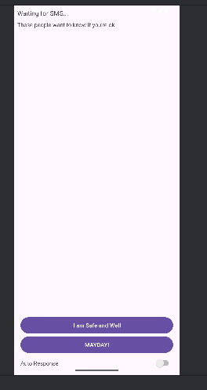
khi mở phone
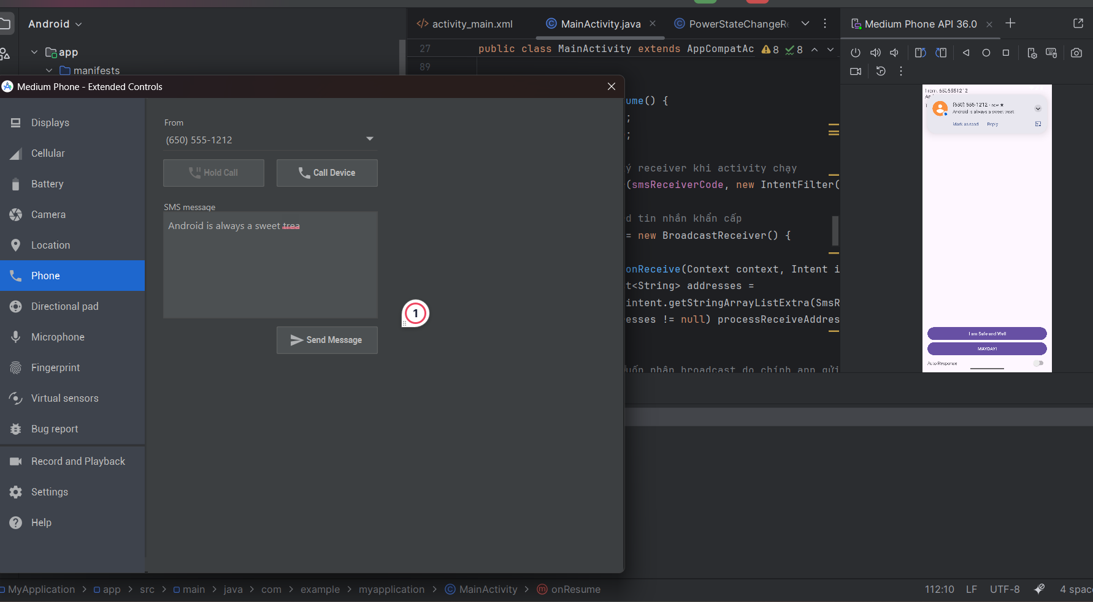
Thử 1 số khác
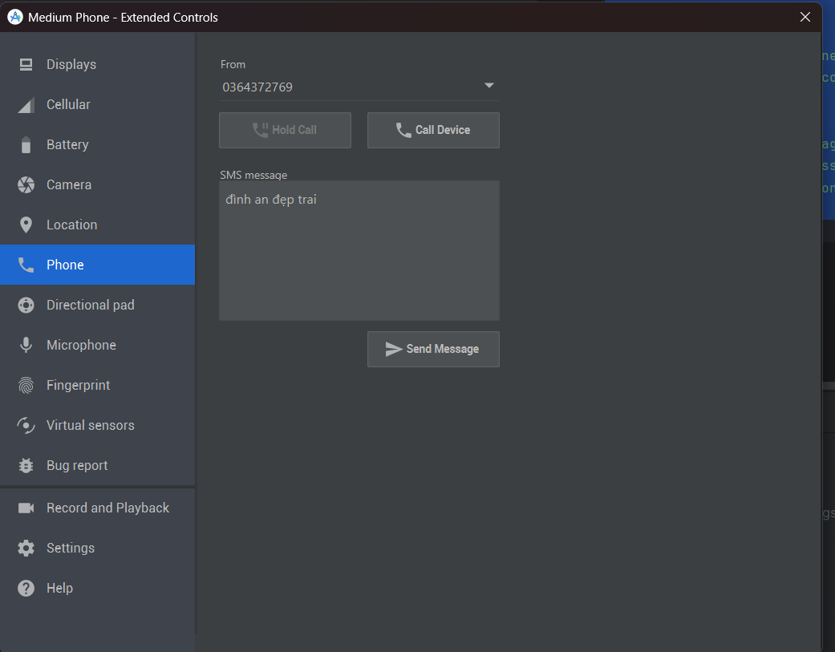

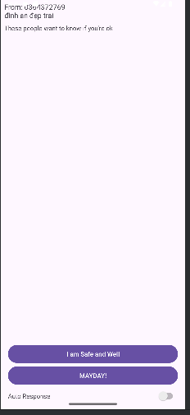

Khi gọi
